Jmeter Fundamentals and Advanced Course Works

Contents

1. Week 2 Course Works: Browser Recording, Running Your First Test, Listener, Reading Test Result 3

# Week 2 Course Works: Browser Recording, Running Your First Test, Listener, Reading Test Result

* Create a Test Plan called “Clinique Search”
* Recording and running a Performance Test for www.clinique.ca website with Search function:
  + Add HTTP(S) Test Script Recorder into WorkBench, then click on Add Suggested Excludes

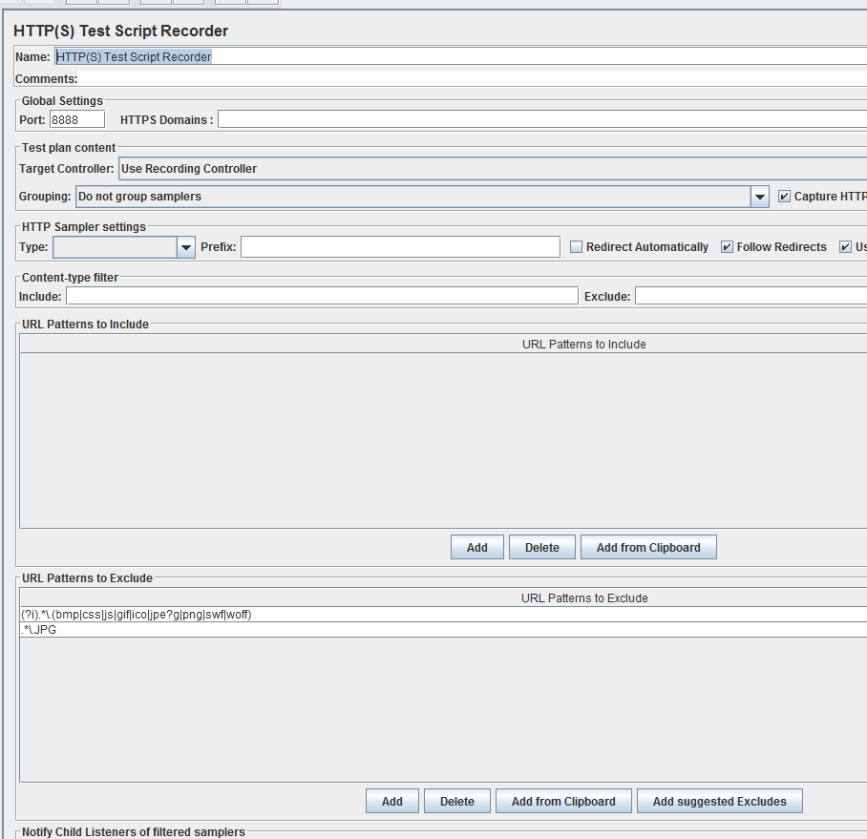

* + Open [www.clinique.ca](http://www.clinique.ca) website
  + Enter “Lotion” in search text-box, then click on Search icon
  + Save Test Plan
  + Add Summary Report, View Result In Table and View Result Tree from Listeners
  + Run Clinique Search Test plan
* Write down the result of the performance test:
  + What is the average response time to run this Test Plan with 5 users in 5 seconds
  + What is the min response time to run this Test Plan with 5 users in 5 seconds
  + What is the max response time to run this Test Plan with 5 users in 5 seconds
  + What is the throughput data of the test?
  + Is there any error occur during the test? If it is, what is the percentage of error?
* Open Jmeter WebsiteTest Plan, add Logic Controllers to each Test Case:
  + Add Random Controller, then copy all 4 TCs (TC1, TC2, TC3, TC4) under this Controler.
  + Add Random Order Controller, then copy all 4 TCs (TC1, TC2, TC3, TC4) under this Controler.
  + Add Loop Controller, then copy all 4 TCs (TC1, TC2, TC3, TC4) under this Controler.
  + Add If Controller, then copy all 4 TCs (TC1, TC2, TC3, TC4) under this Controler.
  + Run Test Plan and see how these controllers work.

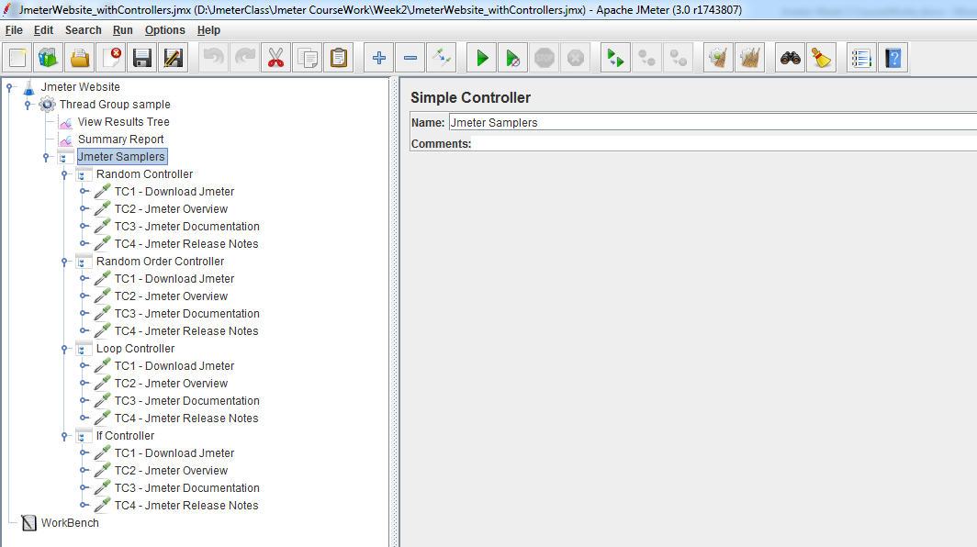

* **Homework**: Create a Test Plan called “Clinique Login”
* Recording and running a Performance Test for www.clinique.ca website with log in function:

(Pre-condition: an account is needed to create before running this test)

* + Add HTTP(S) Test Script Recorder into WorkBench, then click on Add Suggested Excludes
  + Open [www.clinique.ca](http://www.clinique.ca) website
  + Click on “Sign In”, then enter Email Address and Password, then click on “Sign In”
  + After Sign In, click on Sign out
  + Save Test Plan
  + Add Summary Report, View Result In Table and View Result Tree from Listeners
  + Run “Clinique Login” Test plan
* Write down the result of the performance test:
  + What is the average response time to run this search with 5 users in 5 seconds
  + What is the min response time to run this Test Plan with 5 users in 5 seconds
  + What is the max response time to run this Test Plan with 5 users in 5 seconds
  + What is the throughput data of the test?
  + Is there any error occur during the test? If it is, what is the percentage of error?